11/18/2022

**MUHAMMAD NOMAN**

**35152-BSCS**

**Introduction To Python**

**Assignment # 01, 02**

Question # 01:

a = int(input("Enter Number : "))  
if a < 0:  
 print(a, " is Negative")  
else:  
 print(a, " is positive")

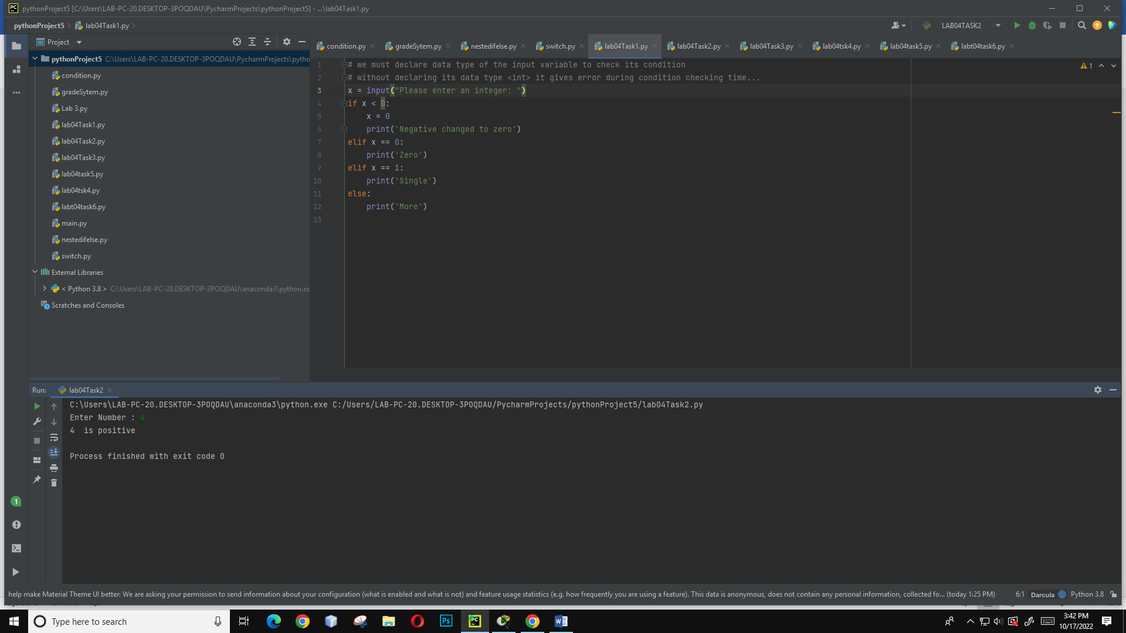

Question # 02:

m = int(input("Enter Number : "))  
n = 0  
if m < 0:  
 print("n = ", n - 1)  
elif m == 0:  
 print("n = ", n)  
else:  
 print("n = ", n + 1)

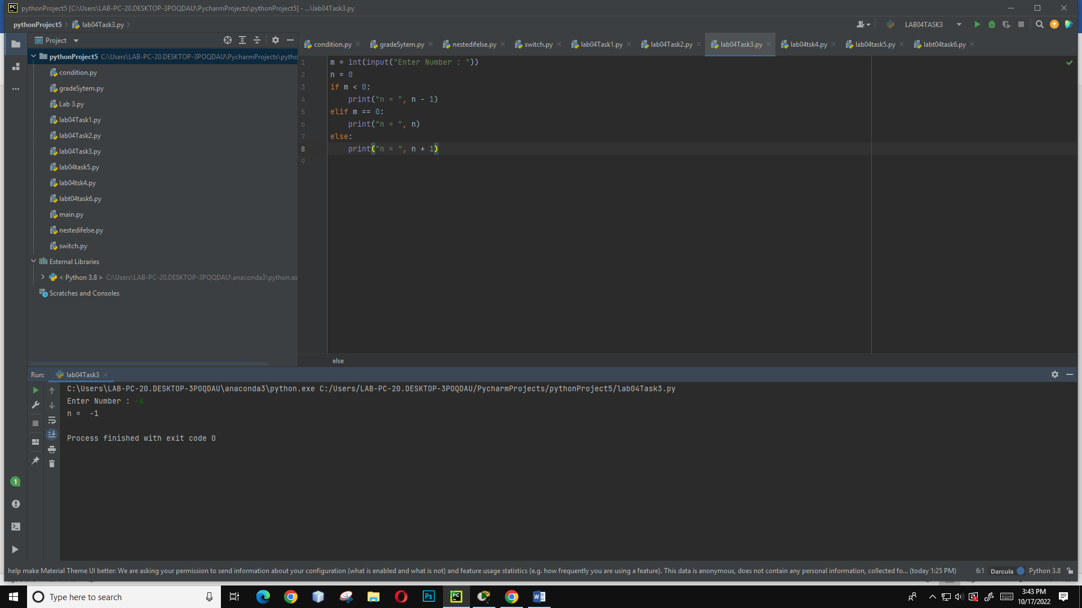

Question # 03:

x = int(input("Enter X : "))  
y = int(input("Enter Y : "))  
  
print("(", x, ",", y, ")", end="")  
if (x < 0 and y < 0):  
 print(" belongs to 3rd Quadrant.")  
elif (x < 0 and y > 0):  
 print(" belongs to 1st Quadrant.")  
elif (x > 0 and y > 0):  
 print(" belongs to 2nd Quadrant.")  
else:  
 print(" belongs to 4th Quadrant.")

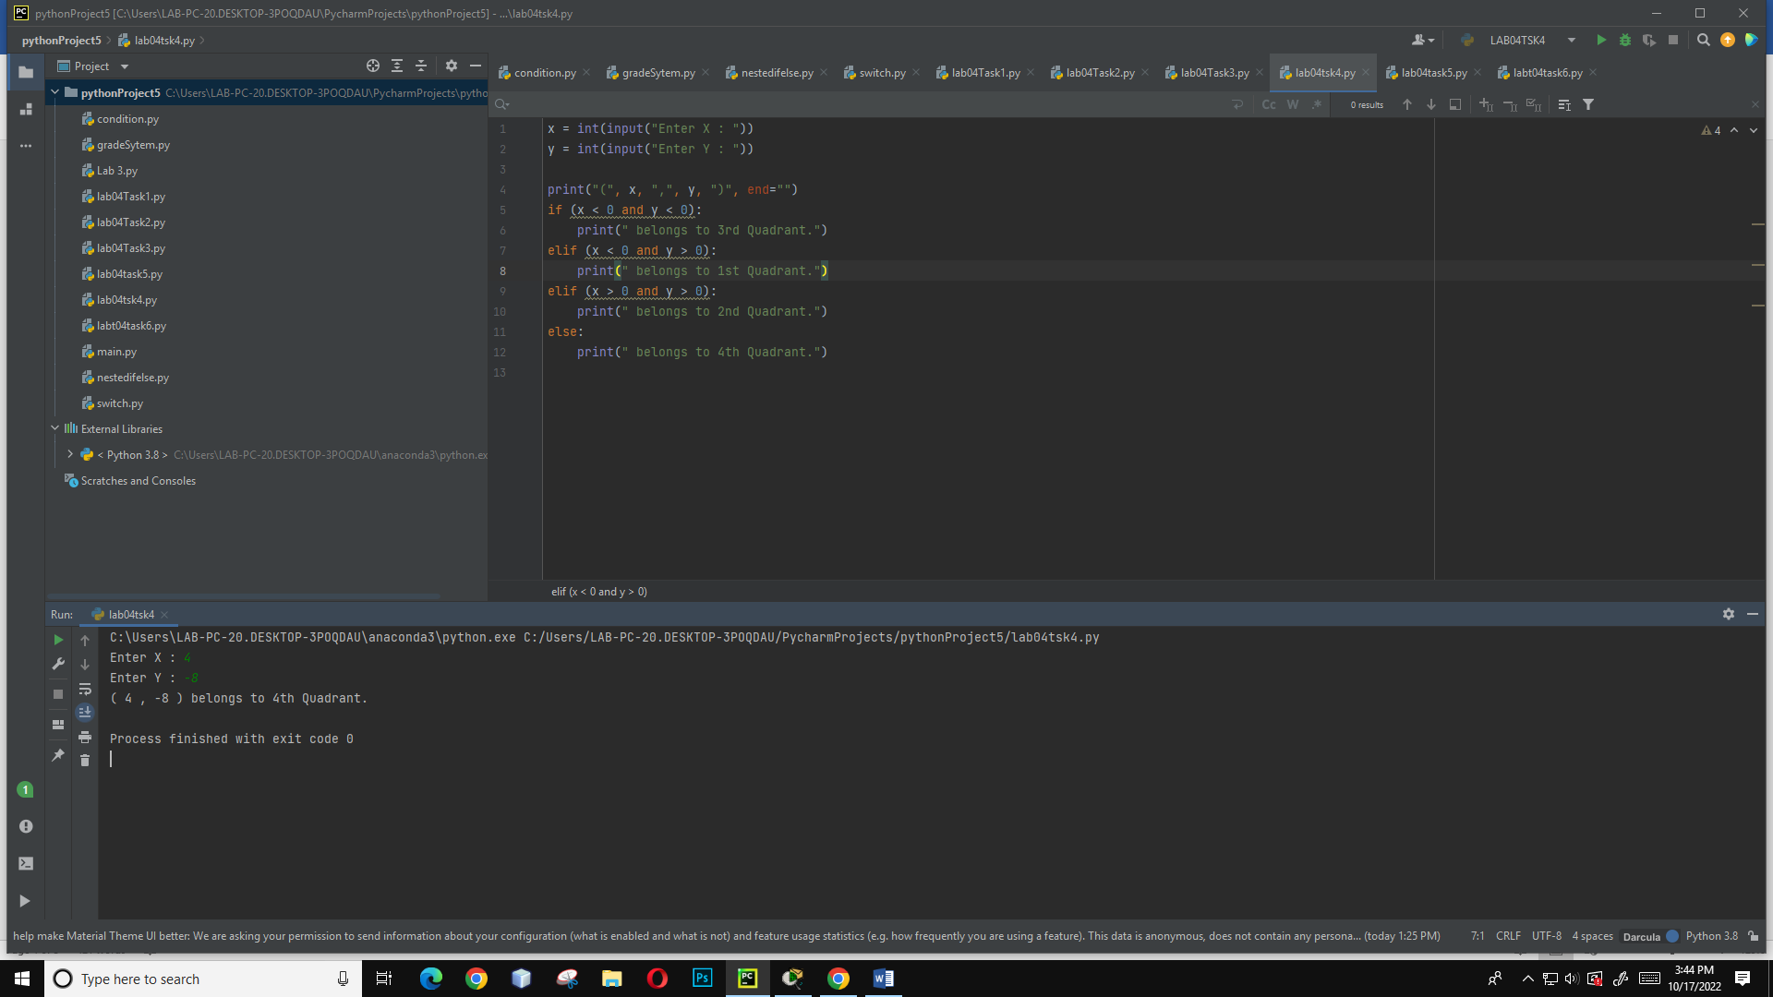

Question # 04:

def addition(num1, num2):  
 num1 += num2  
 return num1  
  
  
def subtraction(num1, num2):  
 num1 -= num2  
 return num1  
  
  
def mul(num1, num2):  
 num1 *= num2  
 return num1  
  
  
def division(num1, num2):  
 num1 /= num2  
 return num1  
  
  
def module(num1, num2):  
 num1 %= num2  
 return num1  
  
  
def default(num1, num2):  
 return "Incorrect day"

switcher = {  
 1: addition,  
 2: subtraction,  
 3: mul,  
 4: division,  
 5: module  
}  
  
  
def switch(operation, num1, num2):  
 return switcher.get(operation, default)(num1, num2)  
  
  
print('''You can perform operation  
1. Addition  
2. Subtraction  
3. Multiplication  
4. Division  
5. Module ''')  
# Take input from user  
choice = int(input("Select operation from 1,2,3,4 : "))  
num1 = int(input("Enter first number: "))  
num2 = int(input("Enter second number: "))  
print(switch(choice, num1, num2))

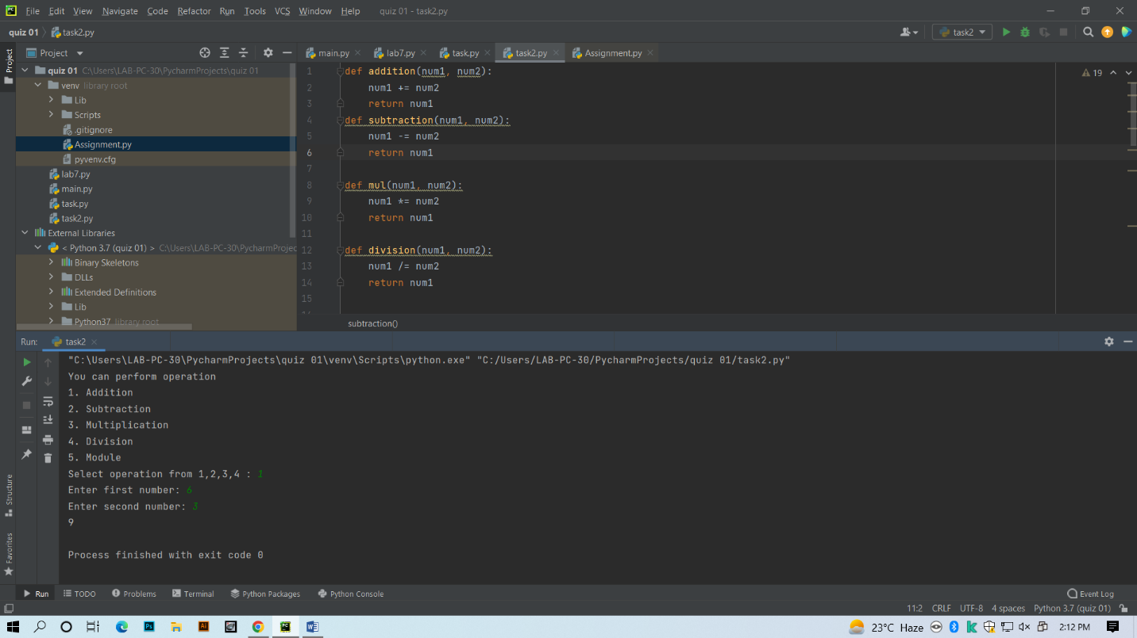

print("Select operation.")  
print("1.Add")  
print("2.Subtract")  
print("3.Multiply")  
print("4.Divide")  
  
while True:  
 # take input from the user  
 choice = input("Enter choice(1/2/3/4): ")  
  
 # check if choice is one of the four options  
 if choice in ('1', '2', '3', '4'):  
 num1 = float(input("Enter first number: "))  
 num2 = float(input("Enter second number: "))  
  
 if choice == '1':  
 print(num1, "+", num2, "=", (num1 + num2))  
  
 elif choice == '2':  
 print(num1, "-", num2, "=", (num1 - num2))  
  
 elif choice == '3':  
 print(num1, "*", num2, "=", (num1 * num2))  
  
 elif choice == '4':  
 print(num1, "/", num2, "=", (num1 / num2))  
  
 next_calculation = input("Let's do next calculation? (yes/no): ")  
 if next_calculation == "no":  
 break  
  
 else:  
 print("Invalid Input")

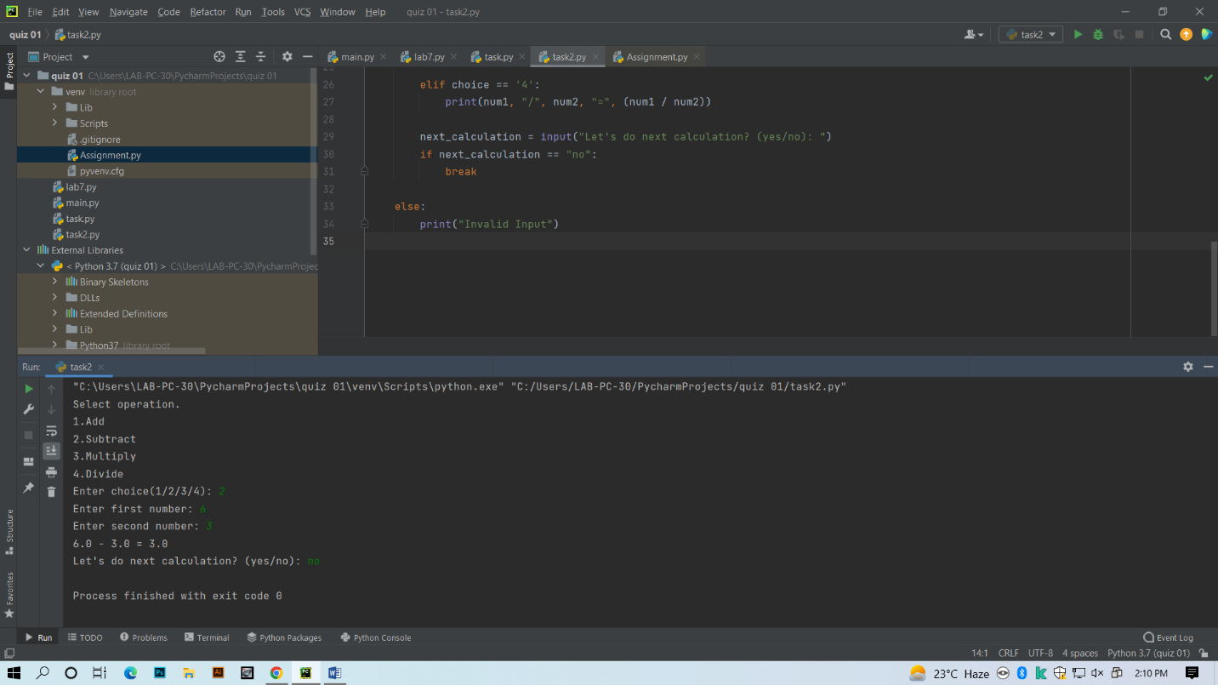

Question # 05:

First_num = int(1500)  
Last_num = int(2700)  
Find = First_num  
print("The Numbers divisible by 7 and 5 are .")  
while Find <= Last_num:  
 if (Find % 35 == 0):  
 print(Find," ")  
 Find += 1

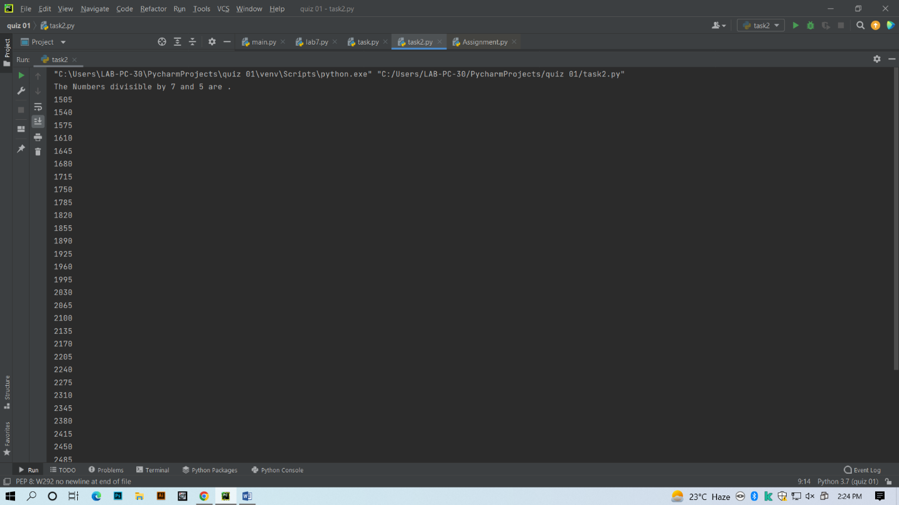

Question # 06:

import math  
num = 5152  
print("The factorial of ",num," is : ", end="")  
print(math.factorial(num))

